Abstract
In this project, we studied why employees leave big companies and how to predict it early.
The problem is that employee attrition causes a lot of financial loss.
We used machine learning and a neural network model to predict future attrition.
After exploring the data and building the model, we achieved good performance with a strong accuracy score.
Finally, we suggest actions the company can take to reduce future employee turnover.

Table of Contents
1. Abstract…………………………………………………………………i
2. Table of Contents…………………………………………………….ii
3. Introduction……………………………………………………………1
4. Data Exploration……………………………………………...………2
4.1 Random Sample of the Data…………………………………2
4.2 Feature Distributions…………………………………………..2
4.3 Double Graphs (Feature vs Left)…………………………….7
4.4 Correlation Heatmap…………………………………………..11
4.5 Summary of Data Exploration……………………………….11
5. Results and Discussion…………………………………………….12
5.1 Data Preprocessing and Model Building………………...12
5.2 Model Performance Comparison ………….……………..12
5.3 Confusion Matrix Analysis…………………………………..13
5.4 Classification Report Analysis……………………………..13
6. Conclusion……………………………………………………………1

Introduction
Employee attrition is when employees leave the company, either by resigning or being fired.
This can cause big problems for companies, including financial loss and delays in work.
To fix this, we can use machine learning to predict which employees might leave.
In this project, we explore employee data, build a prediction model, and suggest solutions based on our analysis.
Our main hypothesis is that factors like satisfaction level, promotions, and salary have a strong effect on attrition.

Data Exploration

4.1 Random Sample of the Data
We selected 10 random samples from the dataset to better understand the features.
The sample shows employee satisfaction levels, evaluations, projects handled, working hours, company department, salary, and other attributes.
salary | sales | Promotion  Last  5years | left | Work  accident | time  spend  company | Average  Monthly  hours | number project | last evaluation | Satisfaction  level
low | sales | 0 | 1 | 0 | 3 | 157 | 2 | 0.53 | 0.38
medium | sales | 0 | 1 | 0 | 6 | 262 | 5 | 0.86 | 0.80
medium | sales | 0 | 1 | 0 | 4 | 272 | 7 | 0.88 | 0.11
low | sales | 0 | 1 | 0 | 5 | 223 | 5 | 0.87 | 0.72
low | sales | 0 | 1 | 0 | 3 | 159 | 2 | 0.52 | 0.37
low | IT | 0 | 0 | 1 | 3 | 219 | 3 | 0.41 | 0.87
low | sales | 0 | 1 | 0 | 5 | 132 | 5 | 0.54 | 0.31
high | sales | 0 | 0 | 1 | 3 | 160 | 5 | 0.75 | 0.74
medium | technical | 0 | 0 | 0 | 6 | 218 | 4 | 0.84 | 0.12
low | technical | 0 | 0 | 0 | 3 | 261 | 4 | 1.00 | 0.70

4.2 Feature Distributions
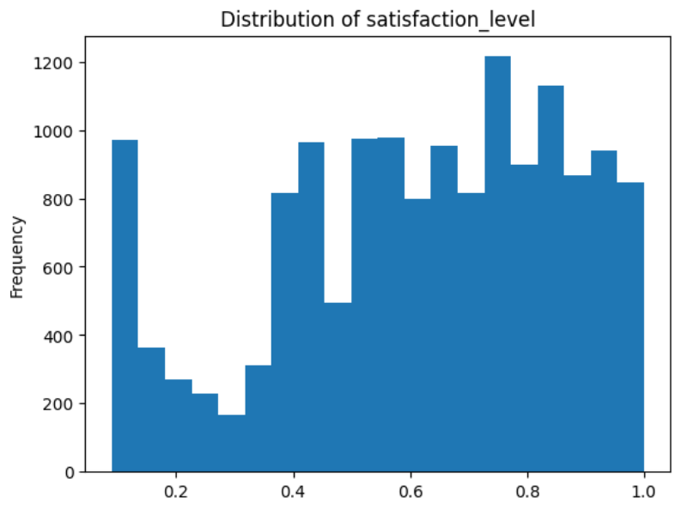
The histogram shows the distribution of employee satisfaction levels across the company.
We notice that many employees have very low satisfaction (around 0.1 to 0.2) and others have high satisfaction (above 0.7).
Having many unhappy employees is a warning sign for higher attrition.

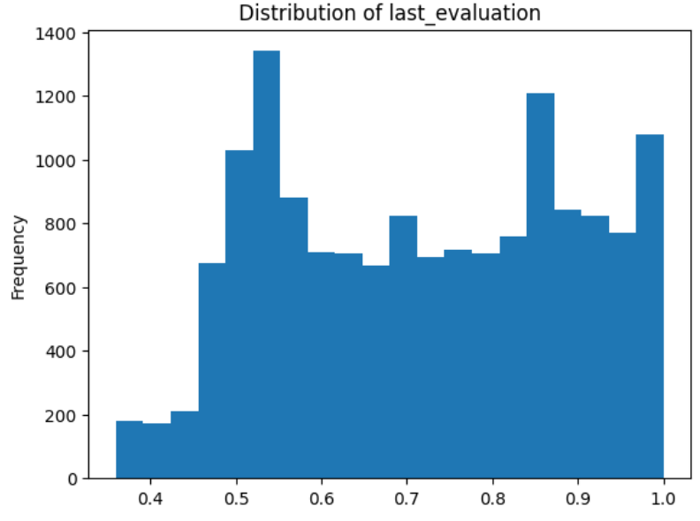
Most employees have evaluation scores between 0.5 and 0.8, with some very high scores near 1.0. High performance does not always mean employees will stay, so it's important to recognize and reward them.

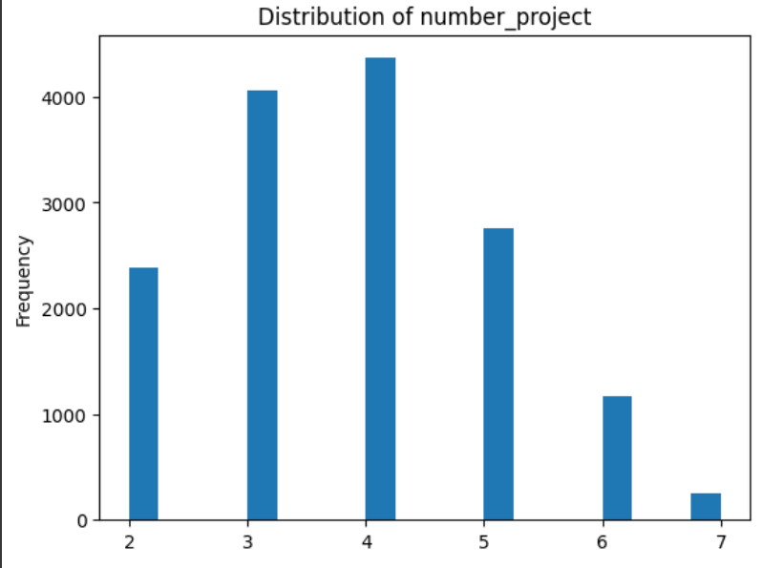
Most employees worked on 3 to 5 projects.
Employees with very few (2) or too many (6-7) projects are more likely to leave, showing that both underwork and overwork can be problems.

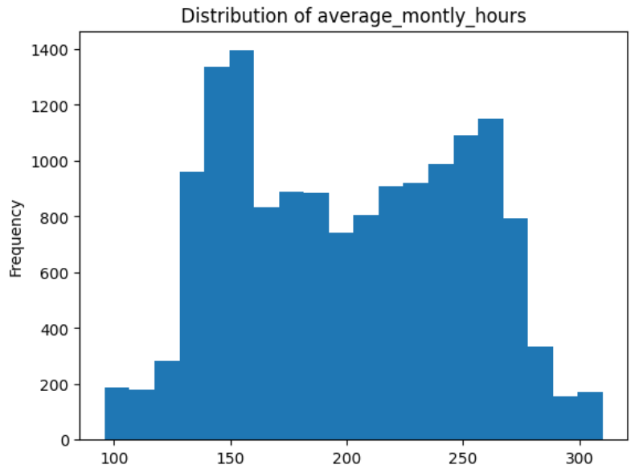
Most employees work between 150 to 250 hours per month.
Employees with very low or very high working hours are at higher risk of leaving due to disengagement or burnout.

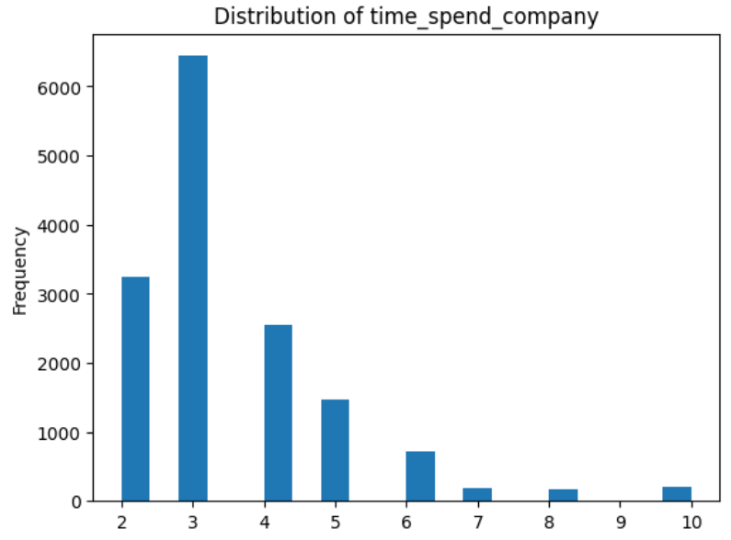
Most employees stayed around 3 to 4 years.
Attrition is more likely after 4 or 5 years if employees don't see growth or changes.

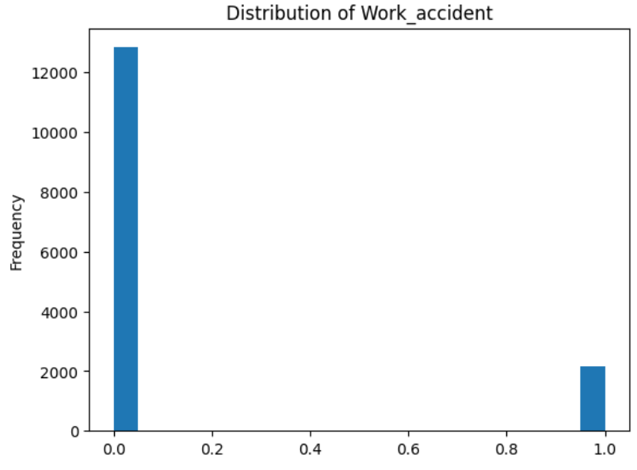
Most employees did not have work accidents.
Work accidents do not seem to be a major cause of attrition, but safety remains important.

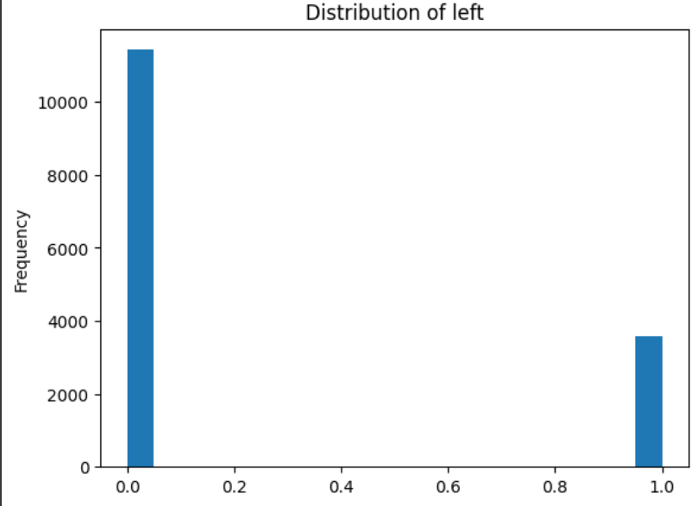
Most employees stayed, but a noticeable group left the company.
Even a small percentage of attrition can be very costly for large companies.

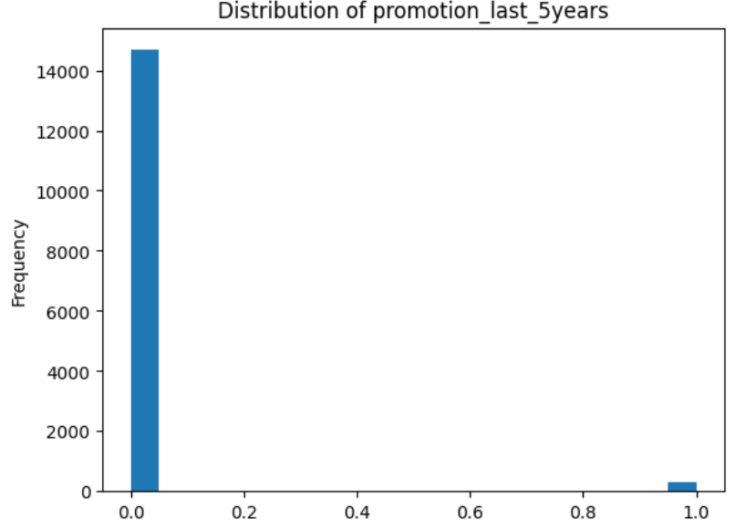
Very few employees received promotions.
Lack of promotion opportunities can lead employees to seek better chances elsewhere.

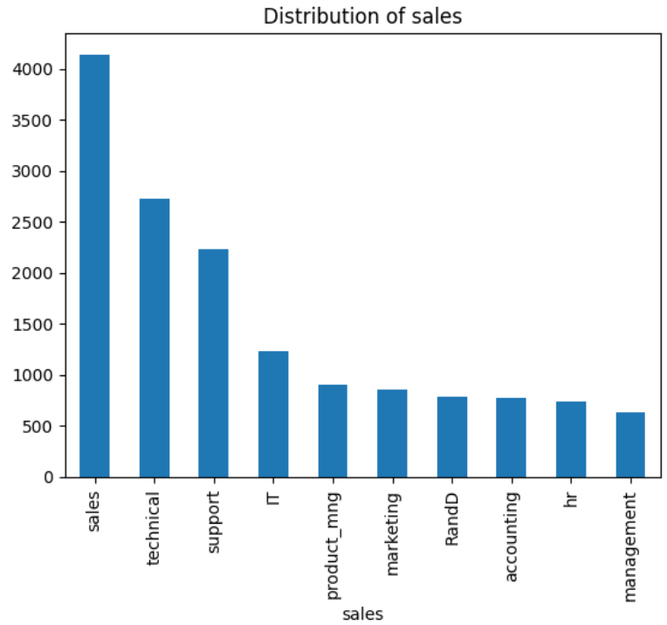
The sales department has the most employees, followed by technical and support.
If attrition happens heavily in sales, it can seriously impact company revenue.

4.3 Double Graphs (Feature vs Left)
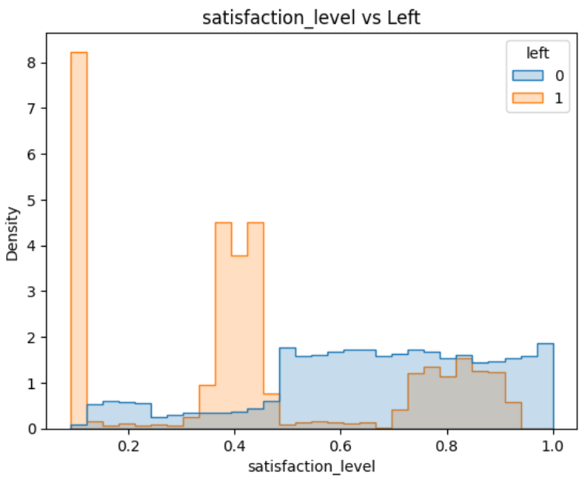
Employees who left mostly had low satisfaction (0.2 - 0.4).
Higher satisfaction strongly connects with employees staying.

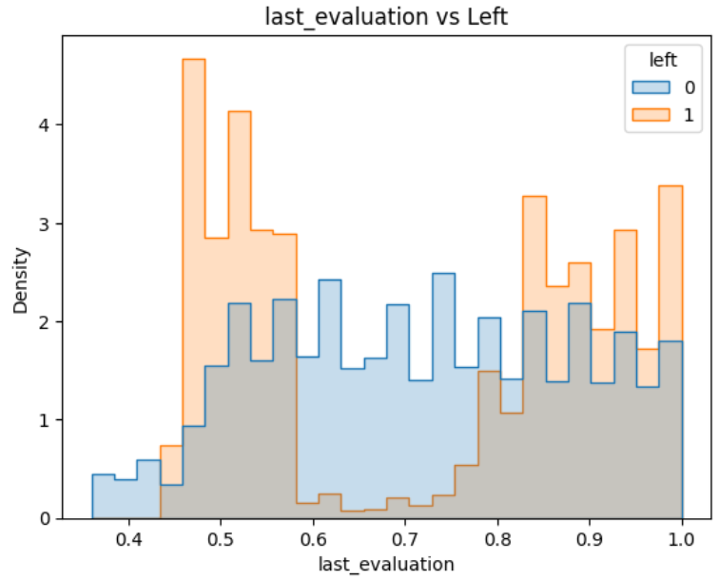
Employees who left had either low evaluation scores (~0.5) or very high ones (~0.9).
Some high performers might leave if they feel unrewarded.

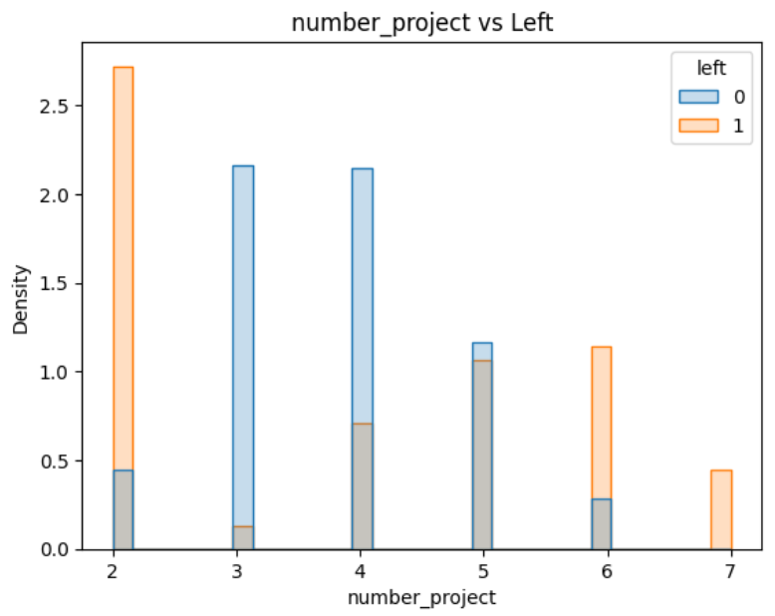
Employees with only 2 projects or more than 6-7 projects had higher chances of leaving.
Workload balance is important.

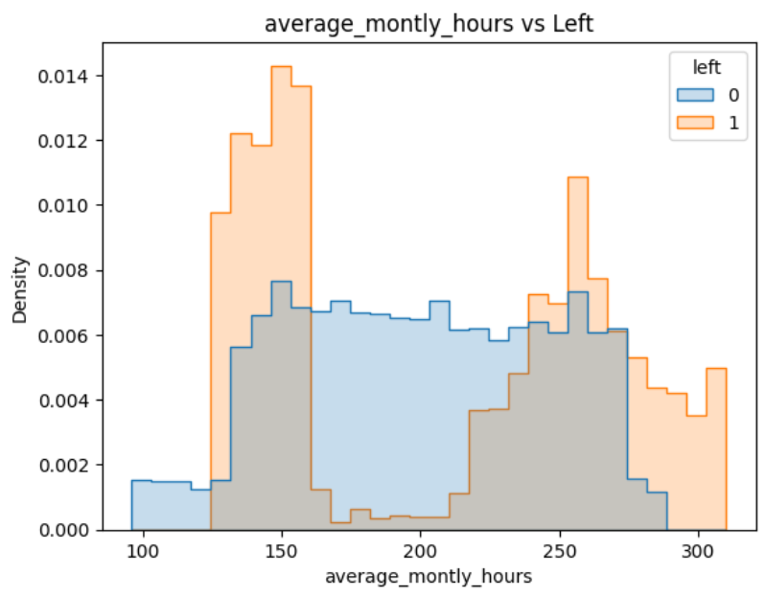
Employees with very low (~150) or very high (~300) working hours left more often.
Managing work pressure is key.

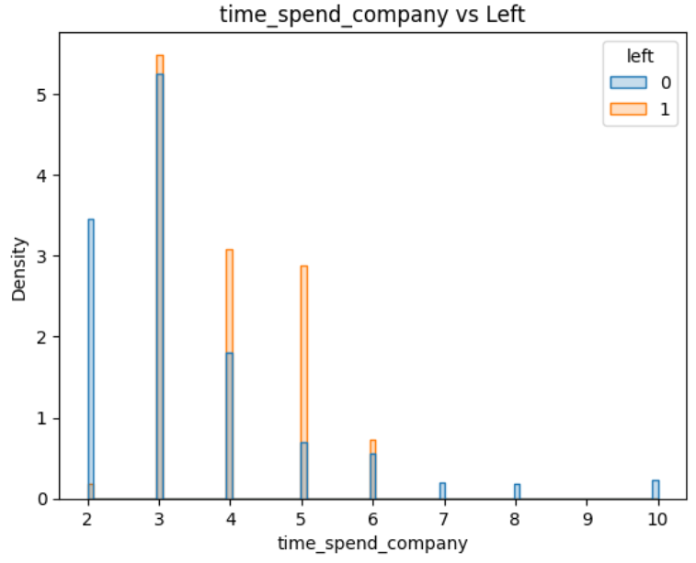
After 4-5 years at the company, employees are more likely to leave.
This shows the importance of career development after a few years.

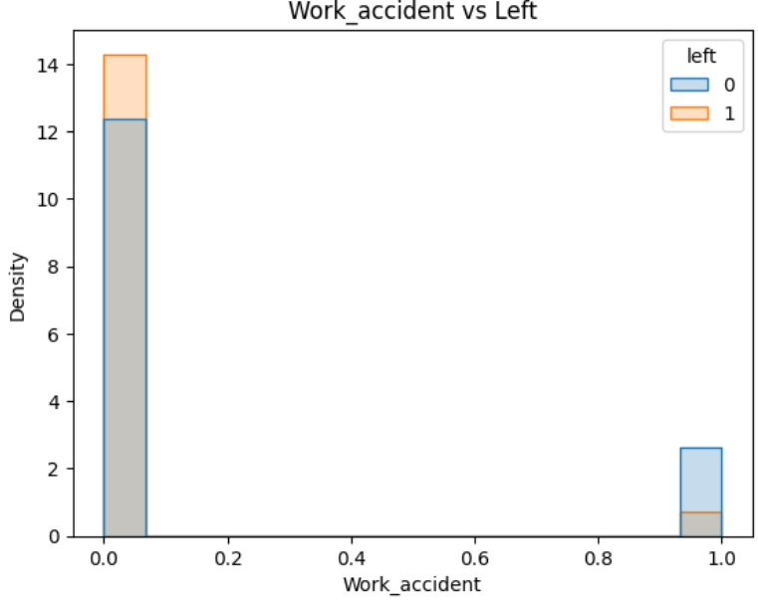
Most employees who had work accidents actually stayed.
Work accidents do not strongly influence attrition.

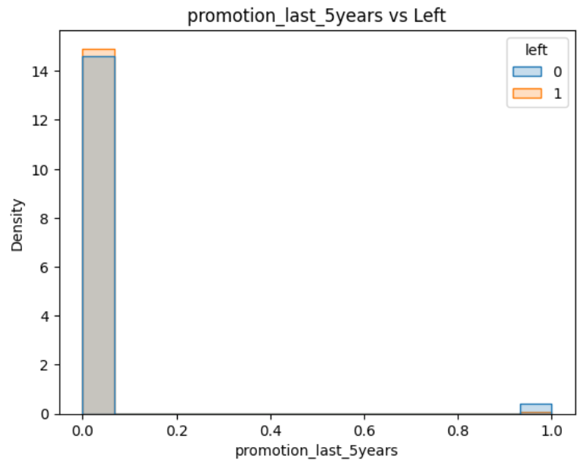
Employees who were promoted were much more likely to stay.
Promotion opportunities reduce attrition significantly.

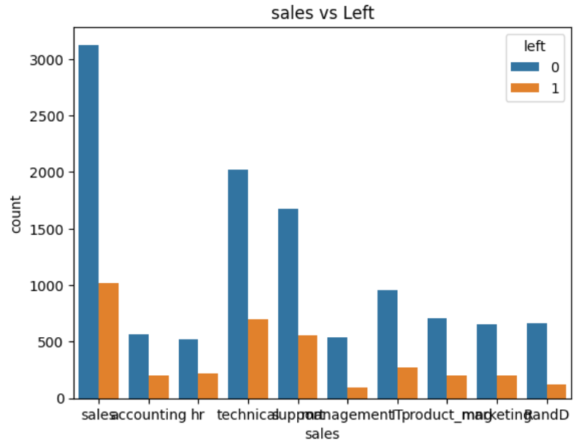
Sales, technical, and support departments had the most employees leaving.
Some departments are at higher risk of attrition and need more attention.

4.4 Correlation Heatmap
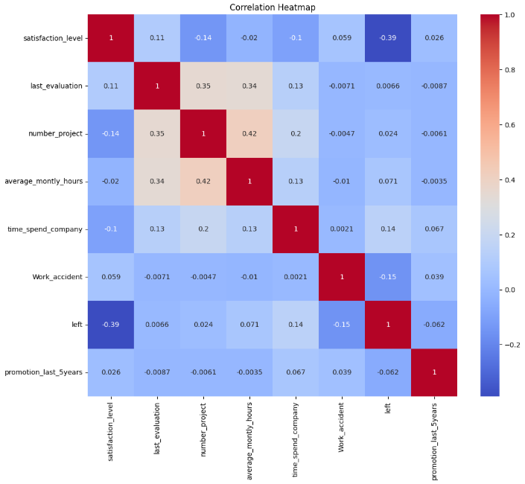
The heatmap shows how different features relate to each other.
The strongest correlation with attrition (leaving) is low satisfaction (-0.39 correlation).
Other factors like time spent in company and number of projects also have small influences.
Overall, satisfaction is the most important factor in predicting whether an employee will leave.

4.5 Summary of Data Exploration
From the data analysis, the main reasons causing employee attrition are low satisfaction levels, lack of promotions, extreme working hours (too low or too high), and staying too many years without career development.
Specific departments like sales and technical had higher attrition rates.
These insights were used to guide the machine learning model building.

Results and Discussion

5.1 Data Preprocessing and Model Building
Before training the models, we prepared the dataset by encoding categorical features like department (sales) and salary level using label encoding. We also normalized the numerical features using StandardScaler to improve model performance.
We then trained four different machine learning models:
MLP (Multi-Layer Perceptron) with two hidden layers using the ReLU activation function.
Naive Bayes classifier for a probabilistic baseline.
SVM (Support Vector Machine) for decision boundary comparison.
Decision Tree classifier to capture non-linear patterns.
All models were trained using the same training and testing split for fair comparison.

5.2 Model Performance Comparison
Recall | F1-score | Accuracy (%) | ML Technique
94.87 | 94.83 | 97.53 | MLP
71.36 | 62.86 | 79.91 | Naïve Bayes
88.90 | 90.72 | 95.67 | SVM
95.90 | 94.97 | 97.58 | Decision Tree

From the comparison:
MLP and Decision Tree performed best overall with high recall and F1-scores.
Naive Bayes performed the worst due to its simplistic assumptions.
SVM had good results but slightly lower than MLP and Decision Tree.

5.3 Confusion Matrix Analysis
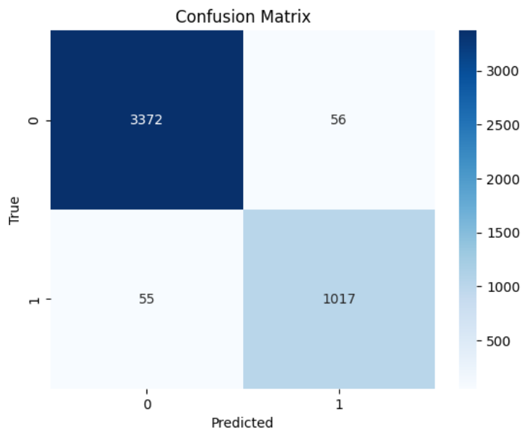
The confusion matrix for the MLP model shows that the model made very few mistakes.
3372 employees were correctly predicted to stay (TP).
1017 employees were correctly predicted to leave (TN).
Only 56 employees were wrongly predicted as leaving (FN).
Only 55 employees were wrongly predicted as staying (FP).
- This means the MLP model can reliably tell which employees might leave and which ones will stay.

5.4 Classification Report Analysis (MLP Model).
The classification report also confirms that the model worked very well.
For employees who stayed, the precision, recall, and F1 score were about 98%.
For employees who left, the scores were around 95%.
The overall accuracy was about 98%, showing that the model is balanced and reliable for both groups.

Conclusion
After exploring the data and building the prediction model, we found that certain factors like satisfaction level, promotions, salary, and work conditions have a big effect on employee attrition.
To reduce the number of employees leaving, the company should focus on improving employee satisfaction, offering fair promotions, adjusting salaries, and managing work pressure better.
By taking these actions, the company can reduce turnover, save money, and keep experienced employees.

